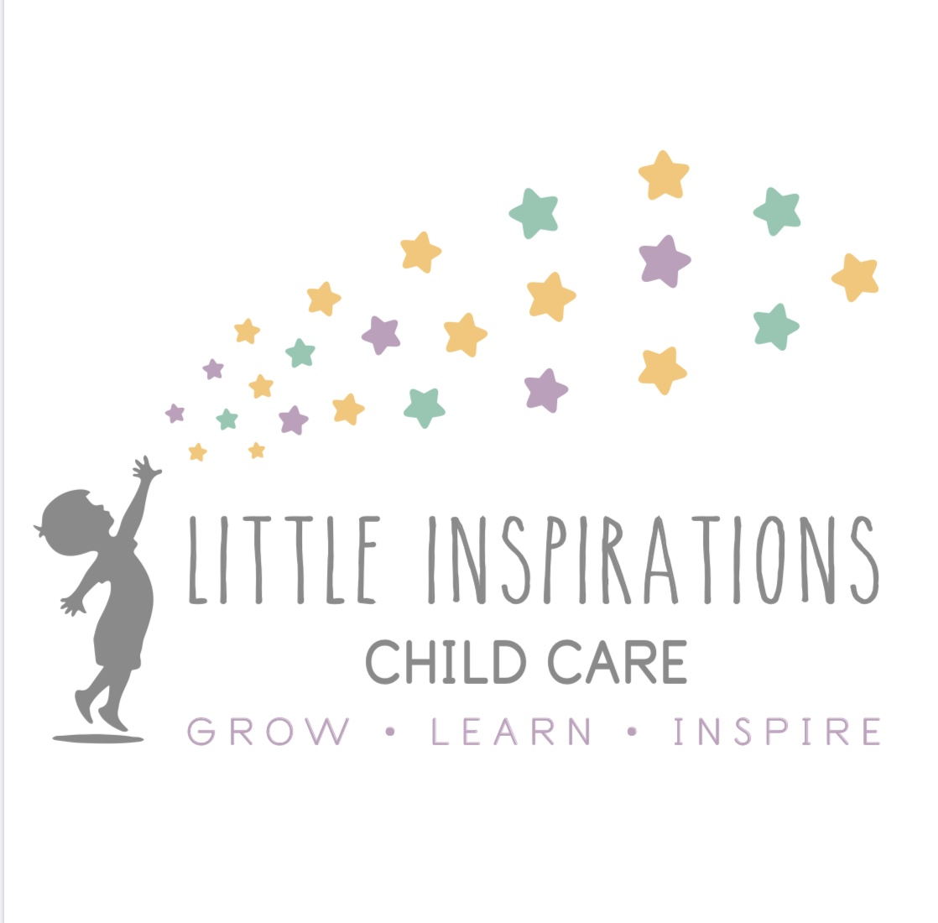Preschool A Classroom
ages 33months- 3.5 years old

Preschool A is where your child moves from the Toddler room, around 33 months of age. This room is licensed for 10 children, and has one teacher. In this classroom, your child will continue to get to know other peers, and begin to learn how to interact with them. This classroom teaches your child about sharing, how we treat our friends and others, and learning self-independence skills. Along with this, they will begin to get acquainted with the alphabet, recognizing their name in print, learning shapes and colors and beginning to master them, and doing other activities that engage their learning.
Daily Focuses
- Learning to share and play with other peers
-Name Recognition ( but not spelling)
-Mastering Shapes and colors
-Letter Introduction—getting to know the letters—songs about different letters (ABC Flip book
-Incorporate calendar, weather, etc
-Theme: Ask a question every day about the monthly theme, talk about it at group time, engage with other friends.

Math Skills: Intro to sorting colors and size

Activity done every day surrounding the theme or seasonal (Art, Math, Music, science)

Incorporate different activities with songs and stories, hands on activities such as counting mats and matching games

Other skills: Introduce cutting

Monthly Focuses
- Turning dramatic play area into a different activity
- Incorporating other learning games and activities matching the theme

