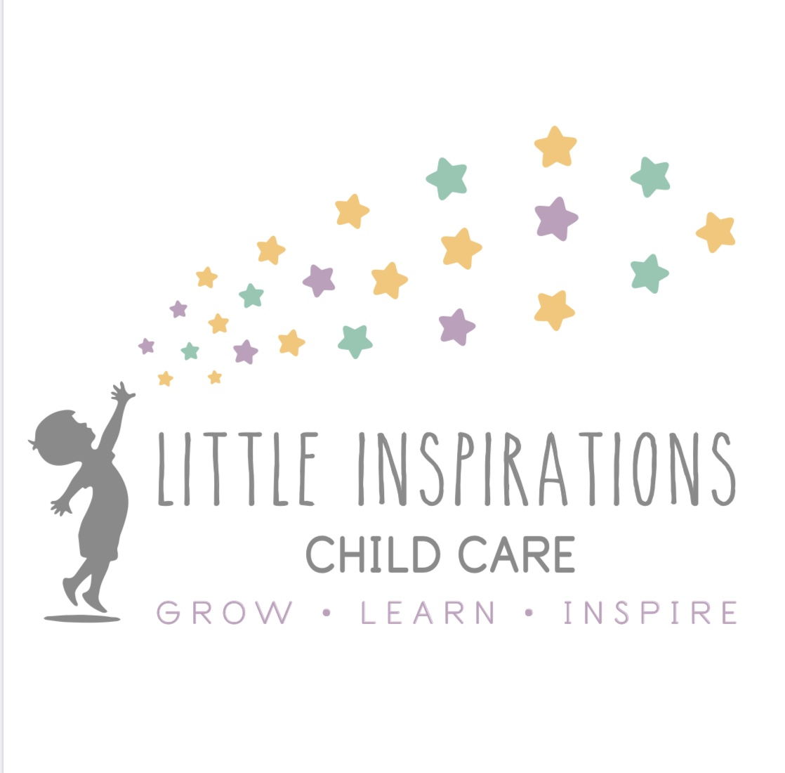Pre-K Classroom
Ages 4-5

In The Pre-K Room we will be getting your child ready to enter Kindergarten. This is their last year before they graduate from our center and head onto Kindergarten. We begin the year out focusing on the alphabet, the letters in their name and writing letters and their name. We use a program called Learning Without Tears which teaches them letter writing and we work on this closely with each child. Our classroom is licensed for 10 children, and as the Directors and owners, Jamie and Kelli share this classroom, to ensure that we are graduation our children from our program with all the tools they will need for Kindergarten. Half way through the school year, we then introduce sight words and begin to start sounding words out and working on how to carry out these sight words into sentences. In the Pre-K room, it is a mix of working on writing and letter sounds, then into sight word learning, as well as working on our self-independence skills, as well as practicing kindness and how to treat others. In this classroom, we also do monthly themes to get the kids engaged in learning through their play areas as well. They are encouraged to learn through our dramatic play areas, writing area, learning games, and block area. We incorporate many different learning aids through the month to get our class engaged in their learning through the theme, while still focusing on letters sounds, recognition and sight words. We also incorporate math signs and working on doing simple math throughout the year. This is done through hands on learning, patterns and sorting, as well as teaching them what the signs of math mean and how to add and take things away, which is mostly done towards the second half of their school year. Our Pre-K program does go through the summer, where we continue to learn about sight words and keep their minds refreshed of all the things they will need to learn and use when they enter Kindergarten.

